 **Government College of Engineering**

**& Research, Avasari (Kh), Pune- 412405**

**Robotic Research Lab, GCOEARA**

(First Year)

Guided By:

**Dr. Niteen P. Futane**

**Assistant Prof. EnTC Dept. GCOEARA**

Submitted By:

**Shravani Ingale (Leader) – EnTC**

**Aditya Pawar - Computer**

**Venu Jangam - Mechanical**

**Hansraj Gaikwad - Mechanical**

**Organized By:**





INDEX

* Problem Statement
* Introduction
* Objective
* Abstract
* Components used
* Block Diagram
* Working
* Future Plans
* Project costing
* Result & Conclusion

PROBLEM STATEMENT

Heavy Schoolbags carried by students cause health issues.

INTRODUCTION

It is a very pleasant sight to see children proceeding toward school. All of them carry school bags of different types and range in sizes. But these are nowadays the biggest drawbacks of school-going children. The heaviness of the bag becomes prominent, and the student seems to drag himself somehow carrying the overweight bag to the classroom. For a long time, the government has been working on reducing the weight in school bags. Multiple schemes and projects have been implemented, but there is no proper solution to this problem. So here we are with a solution of Weighting Buddy.

OBJECTIVE

ABSTRACT

A student should never carry more than 10 percent of his total body weight, but their backpack’s weight today is going as high as 30 percent of their body weight. As a result, it causes several abnormalities. These overweight school bags are today’s concern for both students and parents. Carrying bags heavier than a child’s capacity leads to several serious pains and injuries. Some of these might continue till adulthood. Carrying overweight school backpacks leads to upper and lower back pain and spinal strain. The child might twist his spine while putting or removing the backpack if not take caution and get badly hurt. The extra weight might lead to a hump and make the child a hunchback in the long run. This distortion of back structure might continue even in adulthood and most of them are irreversible.

COMPONENTS USED

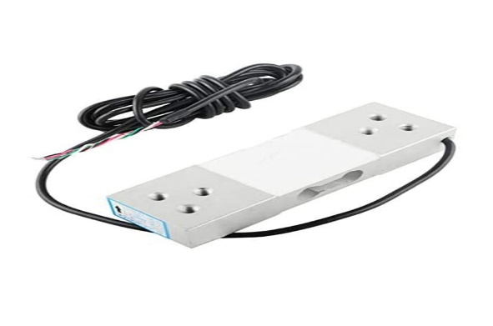Load cell

* The load cell is used in this project to measure the weight of the books.
* The load cell comprises an array of strain gauges that converts the mechanical loads into readable units.
* The force being measured deforms the strain gauge as deformation changes its effective resistance, it generates an electrical signal.

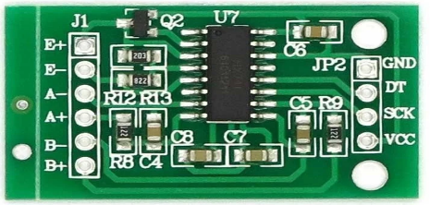HX711 Amplifier

* HX711 is an electronic scale module, which is a 24-bit ADC (Analog to digital converter) that amplifies the low electric output of the load cell.

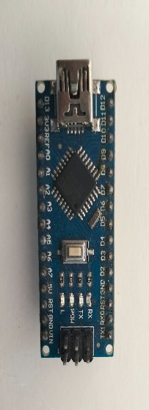

Arduino Nano

Medium-density fiberboard (MDF) is an engineered wood product made by breaking down hardwood or softwood residuals into wood fibers, often in a defibrillator, combining it with wax and a resin binder, and forming it into panels by applying high temperature and pressure.

Medium Density fibreboard

Medium-density fiberboard (MDF) is an engineered wood product made by breaking down hardwood or softwood residuals into wood fibers, often in a defibrillator, combining it with wax and a resin binder, and forming it into panels by applying high temperature and pressure

Electrical Components

|  |  |  |  |
| --- | --- | --- | --- |
| **Name of Component** | **Dimensions**  **(mm)** | **Operating**  **Voltage(V)** | **Diagram** |
| Arduino Nano | 18 X 45 | 7-12 | https://lh3.googleusercontent.com/Q0dFnF-vy2I8SAFlt1Xn_bt1PV6VLuP1mQN9tfgY7zc2Ehm-kncZJOk0CTCAMmZrKamKytALk39eyvOnwT0rIOAvXq6TPxd5JGGsv2cVBvXLzZfTkGsbFnFWMlZ1Xd3-NGk6LpGY |
| Buzzer | Height= 20  Dia= 30 | 3 | https://lh3.googleusercontent.com/8WsciI2MWRvo-XWV3yP4EAI5jZDXfmpcgI-Ex7gO0Lf_tvJIXTPyah0om1cxQhGGEoaG2ba2wlVA9CSSPJJpwYzT-4pyxfbI42LWtwSED69moZRQUmkMyNi6FX3c07vlUeHBmD7f |
| HX711 Amplifier | 34 X 20 | 5.5 | https://lh3.googleusercontent.com/taMABRvjpLdmV0-CQPjByHt6EBI2tRECBgUgZSUCshx9cQXfOoGEQ-zp09WtuxblRzx-BMcnamcdJlLMN2rdDpf704H6gUXWWg4FhJGyEWccb_DGUqJ_Q0OohsJdOyfHG2K_8AbV |
| Load Cell | 130 X 40 X 22  (100 KG) | Output voltage= 0.01 | https://lh3.googleusercontent.com/4eEYMJTxKUi-1XxugqkWG4BXaMovgcJ-IXfZc24WgqW1O3Yxln1XMAC4IbZ1_YpiwWouNfBDQ27g1lSLeXKKyuubcg37zw_gJBAFFJAUfLgmfX-UlWtJL8QwJHqgMKTi7lZmzTL5 |
| Jumper Wires | - | - | https://lh6.googleusercontent.com/aJngTR-gamrYMBTSUJ4IlZGNpGZbtflN4NKlTY_MKQRX2xKs0L_1ow9LvBFHQEiECiW2hnoypEDPgS3cdG13qwBtZuF4Evnld95MhxZgOwoy31mBMAIuLtMw5JOUgjwb9kzL5LYf |
| USB B Cable | - | - | https://lh6.googleusercontent.com/LnoIv2PFEhRHZmFP3U6sscvUdd7HMrf8pRxmF2aV078v9v_5O5KCvHV8eBwAQgOjOi80ivoWZE0EXIORMEx1XCSEJ8lXv0qKjaxX3k1igtQpWf_axp4WywfqZ0-ANDa7iSBljcDO |
|  |  |  |  |

|  |  |  |
| --- | --- | --- |
| **Name of Component** | **Dimensions**  **(mm)** | **Diagram** |
| MDF Board | 300 X 100 | https://lh3.googleusercontent.com/snyLcKWeqbhmzCmneF1cLHErUIun1aYNSUxpyKH6eqzxpDcs_sFXs3mrcFNfuiseTp3kixycluk9u4V5W3hTYbwS0ien8fVcxaJ1d0GRbqqdhVNwI-wBKq44CwFr8CUUJmgRSuiz |

Block Diagram

Working of Our Project

* The Weighting Buddy will be placed at the bottom of the bag so that it can calculate the exact weight of the books.
* The electronics component (other than the load cell) will be placed in a box which will be placed in the side bottle holder and will be connected to the load cell inside the bag.
* When a student start filling his bag the load cell will start calculating the weight.
* When the load
* crosses the mentioned limit, the buzzer will beep, letting him/her know about the extra weight.
* Thus the student can estimate, which books shall he carry so that he doesn’t make the bag heavy and also take all the required material to the school.

FUTURE PLANS

* Reduce weight by using other weight measuring devices
* Reduce the electronic circuit
* Introduce a customizable device that will allow the user to set a weight limit

PROJECT COSTING (ESTIMATED)

|  |  |  |
| --- | --- | --- |
| **Components** | **Quantity** | **Cost** |
| MDF Board | 2 | 60 |
| Screw Headed Bolt  & Nuts | 6 | 30 |
| Arduino Nano | 1 | 370 |
| Buzzer | 1 | 70 |
| HX711 Amplifier | 10 | 30 |
| Jumper Wires | 1 | 30 |
| USB B Cable | 1 | 100 |
|  |  |  |
| **TOTAL** | 22 | 660 |

REFERENCES & NEWS

RESULT & CONCLUSION

Weighing Buddy will let you know the weight inside the bag and if one exceeds the limit of weight, the buzzer will beep letting students know the exact weight he/she shall carry to school